Project Design Phase-II
Technology Stack (Architecture & Stack)

Date
Team ID
Project Name
Maximum Marks

Technical Architecture:
The Deliverable shall include the architectural diagram as below and the information as per the table1 & table 2
Example: Order processing during pandemics for offline mode
Reference: https://developer.ibm.com/patterns/ai-powered-backend-system-for-order-processing-during-pandemics/
Guidelines:
Include all the processes (As an application logic / Technology Block)
Provide infrastructural demarcation (Local / Cloud)
Indicate external interfaces (third party API’s etc.)
Indicate Data Storage components / services
Indicate interface to machine learning models (if applicable)

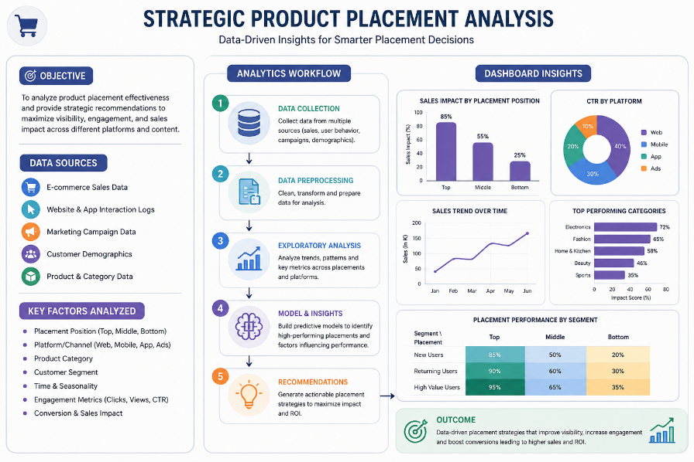

Table-1 : Components & Technologies:
Component | Technology / Tool Used | Purpose
Frontend | HTML5 | Creates the web page structure for the dashboard.
Styling | CSS3 | Designs the user interface and improves appearance.
Backend | Python | Handles application logic and serves web pages.
Web Framework | Flask | Connects the frontend with Tableau dashboard and manages routing.
Data Source | CSV Dataset | Stores product placement and sales data for analysis.
Data Visualization | Tableau Public | Creates interactive charts, dashboards, and stories.
Dashboard Integration | Tableau Embed API | Embeds the Tableau dashboard into the web application.
Development Environment | Visual Studio Code | Used for coding, editing, and debugging the project.
Version Control | Git | Tracks project changes and manages source code.
Repository Hosting | GitHub | Stores the project online and enables collaboration.
Browser | Google Chrome / Microsoft Edge | Displays the Flask web application and Tableau dashboard.
Operating System | Windows 10/11 | Development and execution environment.
Data Processing | Tableau Calculated Fields | Performs calculations such as Average Sales, Profit, and Sales Metrics.
Dashboard Features | Tableau Filters | Allows users to filter data by Product Category, Season, Product Position, Promotion, etc.
Documentation | Microsoft Word | Used to prepare project documentation and reports.

Table-2: Application Characteristics:
Characteristic | Description
Application Name | Strategic Product Placement Analysis
Application Type | Data Analytics & Business Intelligence Dashboard
Domain | Retail Analytics
Purpose | Analyze product placement, pricing, promotions, and customer behavior to improve sales performance.
Target Users | Retail Managers, Store Managers, Marketing Team, Business Analysts
Platform | Web-based Dashboard
Frontend | HTML5, CSS3
Backend | Python Flask
Visualization Tool | Tableau Public
Programming Language | Python
Database/File Source | CSV Dataset
Operating System | Windows 10/11
Browser Support | Google Chrome, Microsoft Edge, Mozilla Firefox
Data Processing | Data Cleaning, Aggregation, Filtering, Calculated Fields
Reports | Interactive Dashboard, Story Points, Charts, Filters
Security | Read-only dashboard access, secure local project files
Performance | Fast dashboard loading with interactive visualizations
Scalability | Can handle additional datasets and more product categories
Availability | Accessible through Tableau Public and Flask Web Interface
Usability | Simple and user-friendly dashboard with interactive filters
Maintainability | Easy to update datasets, dashboards, and visualizations
Portability | Can be deployed on local machine or cloud server
Project Outcome | Helps retailers identify the best product placement strategies and improve sales decisions.

References:

https://code.visualstudio.com/docs
https://help.tableau.com/current/pro/desktop/en-us/default.htm
https://docs.github.com/en

https://docs.python.org/3/

